Installer Project

1. First you will need to create a project in Visual Studio. 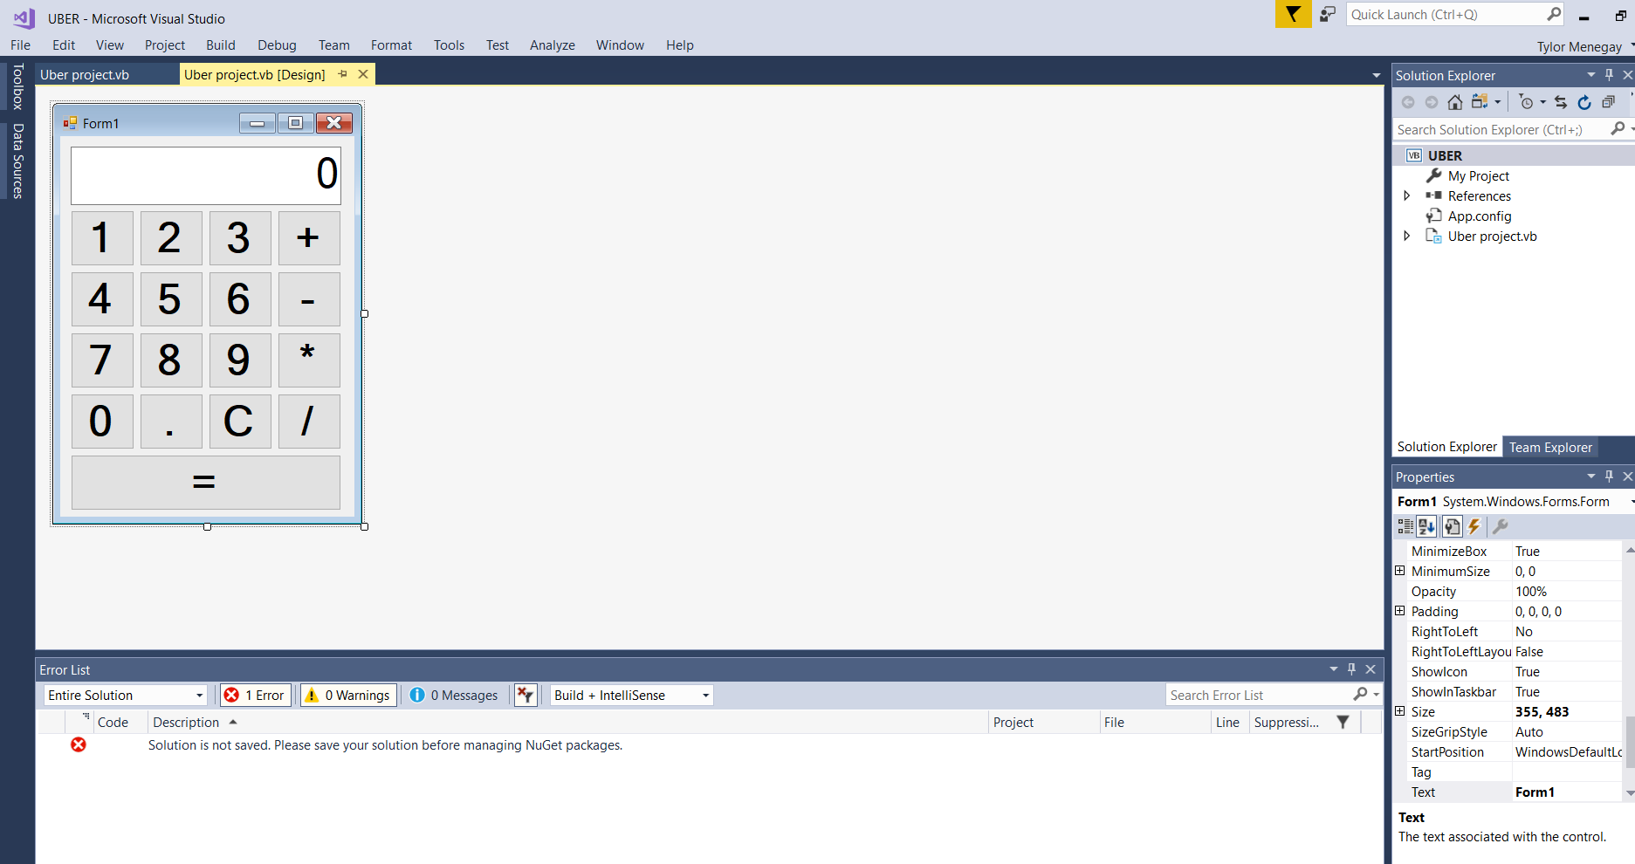
2. Once you have completed your project, you will want to download the 3 installer programs.
3. We will start of with the CreateInstaller. Start by opening it. 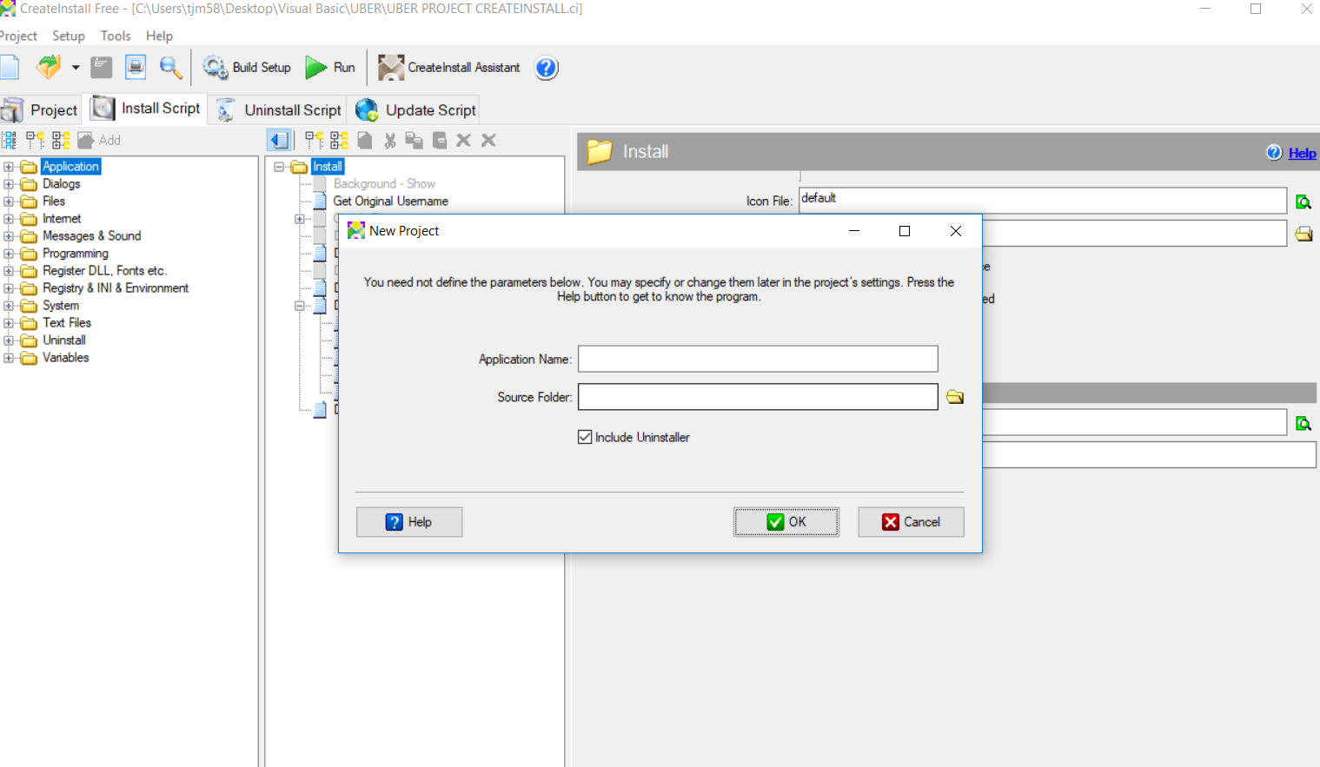
4. You will want to name what you want your application to be called, and then click on the folder icon next to source folder
5. Go into the file you saved your application in and find the debug file, this will be your source file. 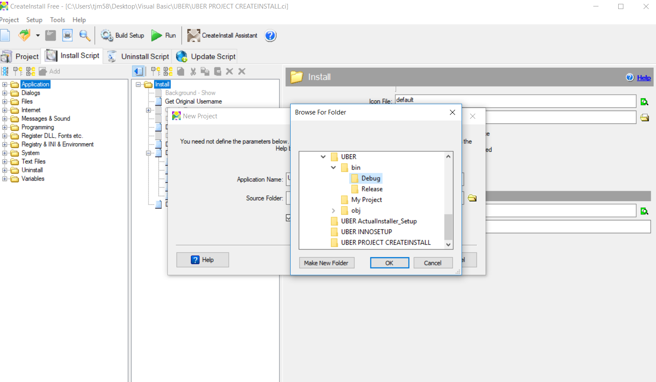
6. Next you will want to click okay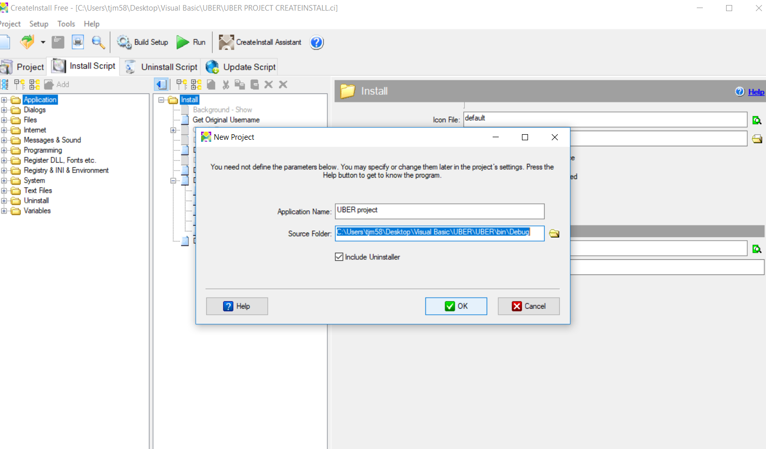
7. Next you will want to click Build Setup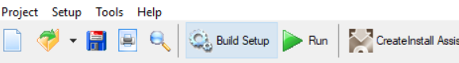
8. It will then create the setup file in a folder of your choosing.
9. This will then install the application for you!

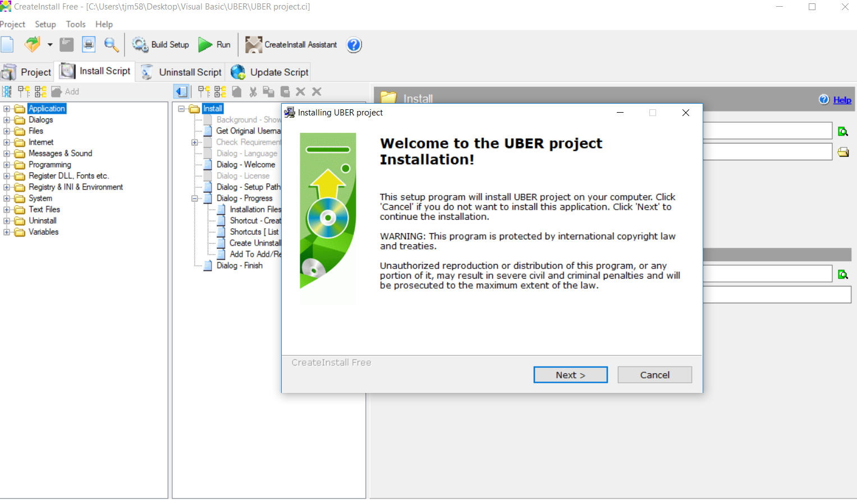

1. Open Actual Installer.
2. Choose to run the free version. 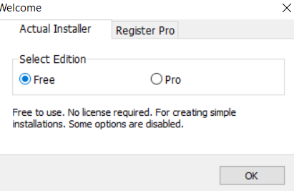
3. Name your project, then select the source folder. This will be your debug folder of the project you created. 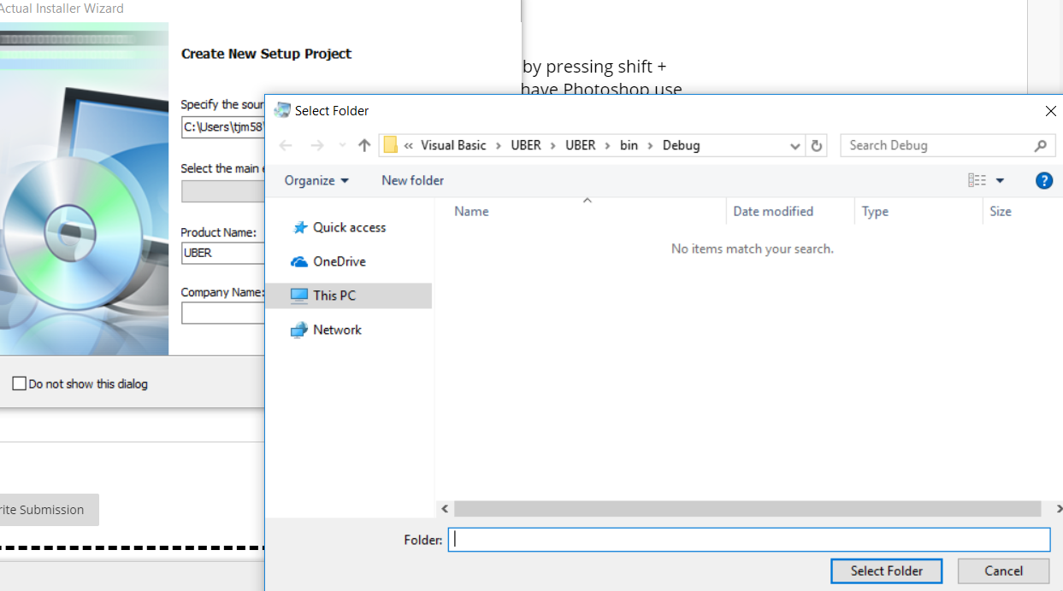
4. Next you will want to click build, to create the setup file. 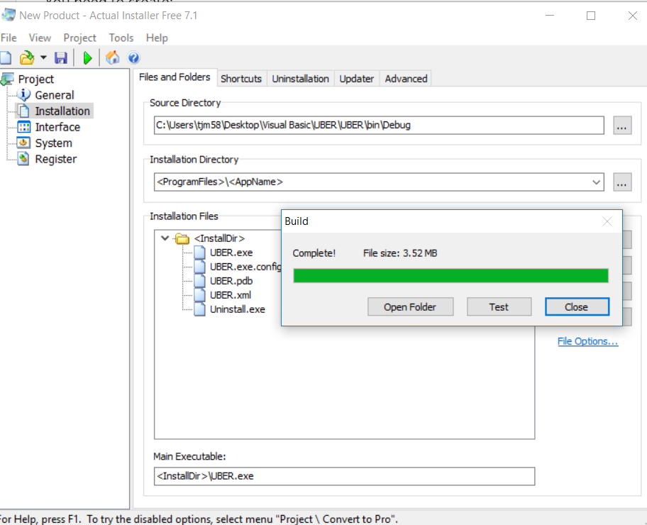
5. You can now run the setup!
6. Now you will want to open Inno Script Compiler. You will want to click create new script file with script wizard.
7. Name your project then click next
8. Choose the folder destination
9. Select the .exe file you want to create.

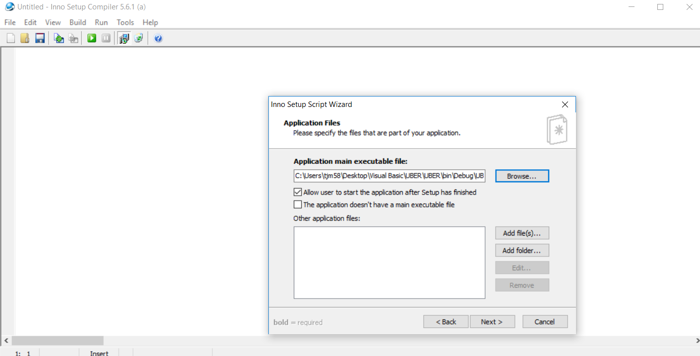

1. Add whatever shortcuts you want on the next page.
2. If you want to add a licensing agreement you may do so on this page, then click next.
3. Then select any languages you want the setup to use then click next.
4. You can change the compiler settings if you want or click next
5. Then you can add a preprocessor then click next
6. Now you can finish to create the setup. 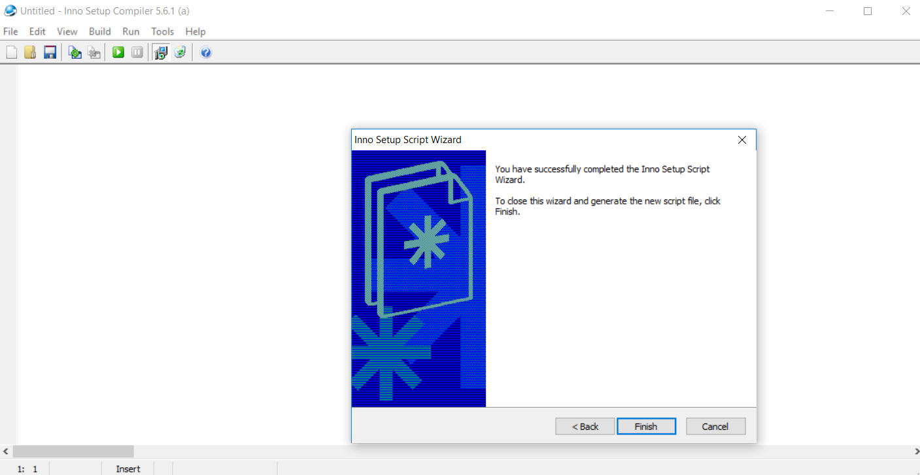

I feel as though the best of the installers was the Inno Setup Compiler. I felt like it had the most features and had the best GUI. For me it was the easiest to use. The one that I liked the least was the CreateInstall application, as it wasn’t very user friendly. I didn’t use any resources to learn how to use these applications so the more user friendly the better. It took me a long time to get a good feel on CreateInstall.